\\erg-fs-p1.mekra.net\MLG\TS-E\04 Wissensdatenbank\Datenblätter\HW\Aktive Bauelemente\LVDS\Maxim\GMSL2\MAX96714\Datasheets\GMSL2_Customers_MAX96714_F_R DS & Reg Doc (rev2).pdf
\\erg-fs-p1.mekra.net\MLG\TS-E\04 Wissensdatenbank\Datenblätter\HW\Aktive Bauelemente\LVDS\Maxim\GMSL2\MAX96714\Application Notes\GMSL2_Customers_max96714fr-user-guide_rev0.pdf

Deserializer:
- Welchen Mode verwenden wir?
  - Pixel mode
  - CSI-2 Forwarding – this one!

MAX96714/F:
- convert a GMSL™2/1 input to MIPI CSI-2 output.
- Simultaneously transmit bidirectional control channel while forward video transmissions are in progress
- forward direction: fixed rate of 3Gbps or 6Gbps
- reverse direction: fixed rate of 187.5Mbps
- Cable
  - low-cost 50Ω Coax, or
  - 100Ω STP (shielded twisted pair)
SION: Inverted Twisted-Pair Serial-Data Input/Output. State of CFG1 on power-up determines configuration.
Configuration:
SoC shall:
- I2Cs of Deserializer configurieren
  - Test message senden (at start-up)
- MFP5 as LOCK konfigurieren
- MFP8 als ERRB konfigurieren
Warum gibt es zwei I2C verbindungen im Deserializer?
Are they one direction connections?
MFP5 is mapped to LOCK indicator
Should MFP6/MFP7 be configured as LMN0/1 i.e. line monitoring?
ERRB:
Tunnel vs Pixel mode is hardwired
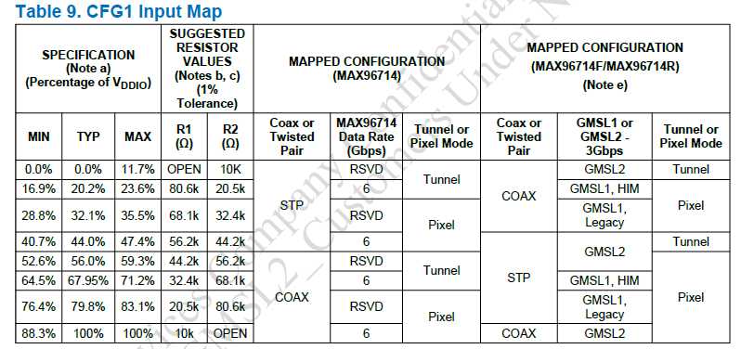
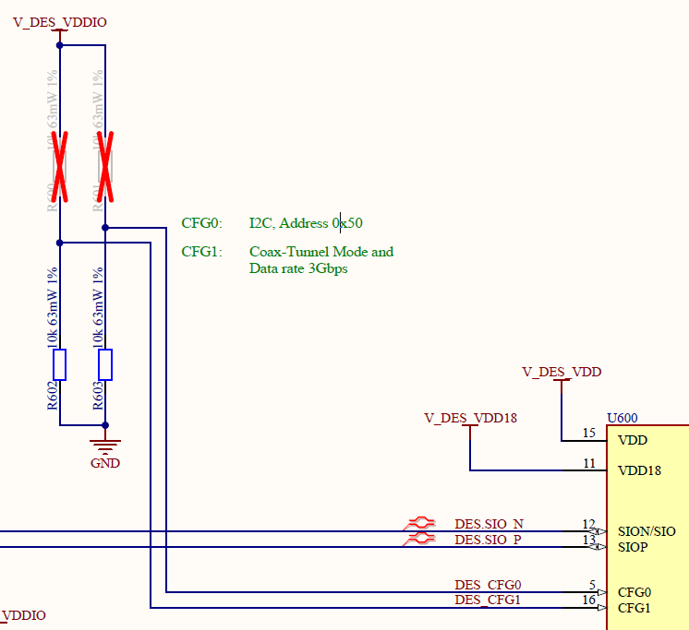

Which i2c is configured this way? (there are two i2cs in the system). What are the device addresses? Is there only one i2c receiver device?
Answer: since R1 is open -> I2C, Address 0x50
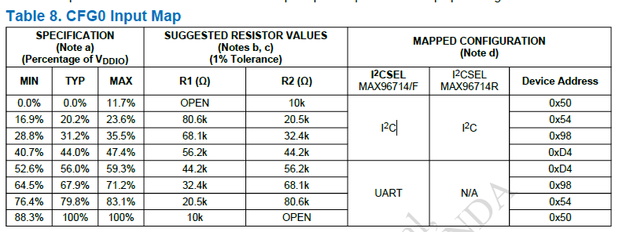
Question:
- What is V_DES_VDD value?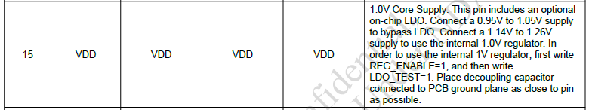
- How long does 1 video line take? (SOW2) -> Agron, see Latency of the chip
- Does the deserializer need the video streaming to be locked? (see also 'lock time')
- Is there a temperature sensor on deserializer? See: Temperature
  - If not, what is the next temperature sensor near the deserializer
    - Is there a temperature model of the ECU (temperature gradient, offset, distribution)?
What CSI-2 data type is required by SOW1? (see: deserializerTunnelModeDataTypes
- )

TSRs:
- The system shall check if VTerm of deserializer is greater or equal to 1.14V and less or equal to 1.26V.
- If it is not the case –> safe state (consider usage of Low level of PWDN -> see here)

- (Assumption: 1.0V nominal voltage, see: Question1)The system shall check if VDD18 of deserializer is greater or equal to 0.95V and less or equal to 1.05V.
- If it is not the case –> safe state

- The system shall check if VDDIO of deserializer is greater or equal to 1.7V and less or equal to 3.6V.
- If it is not the case –> safe state

- The system shall check if junction temperature is less or equal to -40°C and less or equal to 125°C
- If it is not the case –> safe state
- The deserializer shall work in tunnel mode. (checked by review)
  - Note:
    - Is there a way to”get out of tunnel mode” at run-time?
      - What is the system reaction on this?
    - Is there a way to check at run-time if deserializer is in the tunnel mode?
    - Tunnel mode supports better integrity check of the transferred data (end-to-end)
- ??The system (deserializer) shall use Vertical Sync (VS) (MFP0/MFP5) in the context of SG1 (delayed image) – Safety Mechanism, to start counting the ‘Verweildauer’, see:
- ??The system (SoC) shall use Vertical Sync (VS) (MFP0/MFP5(MFP5 is used for LOCK)) in the context of SG1 (delayed image) – Safety Mechanism, to start counting the ‘Verweildauer’
- The system shall use CRC check for SOC <-> Deserializer communication
- The system shall use Message Counter for SOC <-> Deserializer communication
- The system (SoC) when setting parameters shall read back the written value
  - The system shall read periodically the tunnel mode register’s (MIPI_TX52 (0x474)) bit number 0 (TUN_EN). If the value is equali zero (Tunneling disable). The system shall enter safe state.

- The System shall hardwired to support Tunnel Mode. CFG1 == 0V (TunnelModeHardWired1)
- The system (SOC) shall enable tunnel mode of the deserializer by setting register’s (MIPI_TX52 (0x474)) bit number 0 to value 1 (default value is: 0b1), see enableTunnelMode
- The system shall set GMSL2 transmission mode by setting to one the bit GSML2_A of the REG6 (0x6) register (see: LinkInitialization)
- The system shall set I2C transmission mode by setting to one the bit I2CSEL of the REG6 (0x6) register (see: LinkInitialization)
  - Note: This bit is set according to the CFG0 pin value on power-up. Writing to this register is not recommended.
- The system shall check REG6 (0x6) on regular basis (xyz) if the values set at the start-up remain during run time.
- The system shall set cable settings to ‘coax drive’ by setting to one the bit CXTP_A of the CTRL1 (0x11) register (see: LinkInitialization)
- The system shall check CTRL1 (0x11) on regular basis (xyz) if the values (CXTP_A := 1) set at the start-up remain during run time.
- Any changes to the GMSL link should be followed by a link reset to reinitialize the link (toggle RESET_LINK HIGH and then LOW or write 1 to RESET_ONESHOT bit of the CTRL0 (0x10) register).
- System needs to be configured to receive LOCK on the MFP5 (see: LockOnMFP5), Related to SM6 of Deseserializer
- System shall check on regular basis if MFP5 is still serving the LOCK indication! Related to SM6 of Deseserializer (see: LockOnMFP5), by checking VS, DE and GPIO5 settings being disabled.
  - Alternatively!Check the bit number 3 of CTRL3 (0x13) register
    - 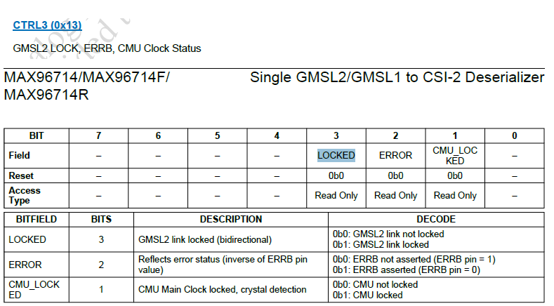
- While in starting mode, the system shall select one of the four streams from the serializer. The stream ID shall match the one of the serializer. (see: p. 13 applNotes, see: SelectingPipeStream) by setting bits VIDEO_PIPE_EN[1:0] to 0b01 of register: VIDEO_PIPE_EN (0x160) and setting bits VIDEO_PIPE_SEL_Y[2:0] to appropriate stream ID (preferably 0b010) of register: VIDEO_PIPE_SEL (0x161)
- The system shall enable CRC packet and message counter to monitor both write and read transactions (see: I2C for CRC + Message Counter) by doing the following:
  - Set bit CC_CRC_EN to one, of the register I2C_UART_CRC7(0x300F)
  - Set bit CC_CRC_MSGCNTR_OVR to one, of the register I2C_UART_CRC7(0x300F)
  - Set bit CC_MSGCNTR_EN to one, of the register I2C_UART_CRC7(0x300F)
  - Set bit CC_CRC_MSGCNTR_OVR to one, of the register I2C_UART_CRC7(0x300F)
- The system (Component:SoC) shall configure the serializer and imager via i2c connection of the deserializer, see: ECU_RS_438 of the \\erg-fs-p1.mekra.net\MLG\TS-E\ASPICE-FuSi Engineer\projekte\VOLVO\SOW2\SOW1\CH3SVC_VT_ECU_RS_17v2_PRELIMINARY_20251022.pdf of SOW1(BOSCH camera)
- The HOST SYSTEM shall permanently store (non volatile) the settings of Imager chip in the
- Camera Head. The config data shall not be corrupted in the HOST SYSTEM neither during OFF nor ON time., see: ECU_RS_331 of the \\erg-fs-p1.mekra.net\MLG\TS-E\ASPICE-FuSi Engineer\projekte\VOLVO\SOW2\SOW1\CH3SVC_VT_ECU_RS_17v2_PRELIMINARY_20251022.pdf of SOW1(BOSCH camera)
- The HOST SYSTEM shall protect the sending of configuration data to Imager by insertion of CRC Checksum of I2C messages. note: it is safety mechanism to protect the Imager configuration during the data transmission from HOST SYSTEM to Imager chip. see: ECU_RS_366 of the \\erg-fs-p1.mekra.net\MLG\TS-E\ASPICE-FuSi Engineer\projekte\VOLVO\SOW2\SOW1\CH3SVC_VT_ECU_RS_17v2_PRELIMINARY_20251022.pdf of SOW1(BOSCH camera)
- The HOST SYSTEM shall protect the sending of configuration data to Imager by insertion of "Message Counter" in addition to the CRC Checksum, ECU_RS_472 of the \\erg-fs-p1.mekra.net\MLG\TS-E\ASPICE-FuSi Engineer\projekte\VOLVO\SOW2\SOW1\CH3SVC_VT_ECU_RS_17v2_PRELIMINARY_20251022.pdf of SOW1(BOSCH camera)

Initialization procedure:
- CFG0 has hardwired I2C mode and address, this value is read during start-up and latched into the REG6 (0x6):: I2CSEL
- CFG1 has hardwired Cable & GMSL & Mode
  - the GMSL value is read during start-up and latched into the REG6 (0x6):: GMSL2_A
  - the Cable value is read during start-up and latched into the CTRL1 (0x11):: CXTP_A
- Set GMSL2 mode by setting bit number 6 of REG6 (0x6) to 1 (GMSL2_A := 1)
- Set GMSL2 mode by setting bit number 4 of REG6 (0x6) to 1 (I2CSEL := 1)
- Set Cable by setting bit number 0 of CTRL1 (0x11) to 1 (CXTP_A := 1)
- Perform reset by setting bit number 5 CTRL0 (0x10) to 1 (RESET_ONESHOT:=1)
  - Note: A link reset on CSI-2 deserializers resets the entire data path of any video connected to the reset PHY. Do not use link resets when video is being fed to the device. Doing this may corrupt data and have unintended consequences.
Temperature
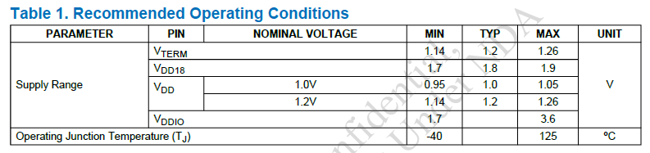
PWDNB, Lock time
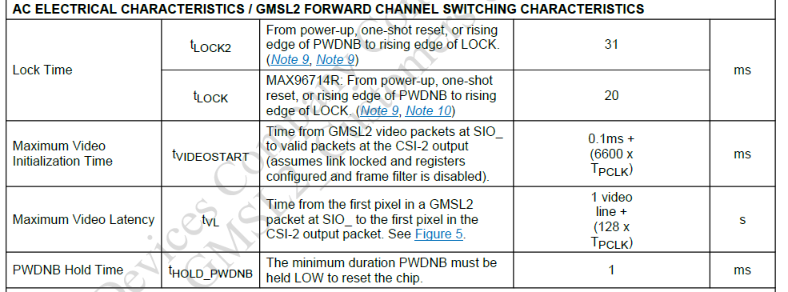

Latency of the chip:
- 1 video line + 128 * TPCLK == 38.4us + 0.0017us == 38,4017us
- For GMSL2 600MHz TPCLK == 0.0017us
- Question to Co-pilot: how long does one video line transmission take in the GMSL 6Gbit protocol?
The GMSL (Gigabit Multimedia Serial Link) protocol, particularly in its 6 Gbps variant, is designed for high-speed video transmission in automotive and industrial applications. However, the transmission time for a single video line depends on several factors:

🔢 To estimate the time to transmit one video line, we need:
- Line size in bits (depends on resolution and color depth)
- Effective data rate (after accounting for protocol overhead)

📘 Example Calculation (Assuming 1920×1080 @ 60 Hz, RGB 24-bit):
- Pixels per line: 1920
- Bits per pixel: 24 (8 bits per RGB channel)
- Bits per line:
$1920 \times 24 = 46,080 \text{ bits}$
- Raw GMSL bandwidth: 6 Gbps
But effective payload throughput is typically lower due to encoding (e.g., 8b/10b or 128b/132b), control symbols, and protocol overhead.
Assuming 80% efficiency: $6 \text{ Gbps} \times 0.8 = 4.8 \text{ Gbps effective}$
- Transmission time per line: $\frac{46,080 \text{ bits}}{4.8 \times 10^9 \text{ bps}} \approx 9.6 \, \mu s$

⚠️ Notes:
- This is a simplified estimate. Real-world values depend on:
  - Protocol overhead (e.g., framing, sync, CRC)
  - Compression (if used)
  - Line blanking intervals
  - Forward error correction (FEC)
- GMSL2 and GMSL3 variants may have different efficiencies and encoding schemes.

Would you like a calculator or script to estimate this for different resolutions or frame rates?
  - For 1920 pixels per line, 24 bits per channel and 4 channels (RAW image) > 38,4us

Maximum Video initialization time:
0.1ms + 6600 * TPCLK == 0.1ms + 6600 * 0.0000017ms == 0,111 ms

Question to Copilot: hi! could you please explain the notion of 'lock time' in the GMSL2 protocol?
In the context of the GMSL2 (Gigabit Multimedia Serial Link 2) protocol, lock time refers to the duration it takes for the serializer and deserializer to establish a stable communication link after configuration or reset. This process ensures that both ends of the link are synchronized and ready to transmit and receive data reliably.

Here's how lock time fits into GMSL2 operation:

🔧 Link Initialization Process
When a GMSL2 link is powered on or reconfigured, the following steps occur:
- PHY Detection: The serializer detects which physical interface (PHYA or PHYB) is connected to the deserializer.
- Link Reset: A reset is triggered to apply new configuration settings.
- Canceller Calibration: The system calibrates the canceller to mitigate channel impairments.
- Equalizer Adaptation: The equalizer adjusts to the channel characteristics to ensure signal integrity.
- Link Establishment: The serializer and deserializer synchronize and begin communication.
- LOCK Pin Assertion: Once the link is successfully established, the LOCK pin is pulled high to indicate a stable connection.

⏱️ Typical Lock Time
- The entire process typically takes less than 50 milliseconds.
- This includes reset, calibration, equalization, and link-up steps.

📘 Auto vs Manual Link Mode
- Auto Link Mode (AUTO_LINK = 1) simplifies the process by automatically detecting and configuring the link.
- Manual Link Mode (AUTO_LINK = 0) allows precise control but may increase lock time due to manual configuration steps.

📍 Example from the User Guide
When switching from splitter mode to single-link mode, the serializer performs a “One-shot Reset” and the following sequence:
- Reset the link
- Self-clear the reset bit
- Recalibrate the canceller
- Auto-adapt the equalizer
- Link up to the deserializer
- Pull the LOCK pin high
This sequence defines the lock time for the GMSL2 link.[1]
Would you like help interpreting register settings or optimizing lock time for a specific application?
References
[1] www.analog.com

Question to Copilot: can slave initiate a message transfer to master in i2c protocol?

In the I²C (Inter-Integrated Circuit) protocol, slaves cannot initiate communication with the master. Here's a breakdown of how it works:

🔄 I²C Communication Basics
- Master: Initiates and controls all communication on the bus.
- Slave: Responds to requests from the master.

❌ Slave-Initiated Communication?
- Not possible directly: The I²C protocol is designed such that only the master can generate the START condition, which begins a data transfer.
- Slaves are passive: They wait for the master to address them and then respond accordingly.

✅ Workarounds for Slave Notification
While slaves can't initiate communication, there are techniques to alert the master:
- Interrupt Line (e.g., GPIO):
  - A slave device can pull a dedicated interrupt line low to signal the master that it has data ready.
  - The master then polls or reads the slave via I²C.
- SMBus Alert Protocol:
  - In System Management Bus (SMBus), which is based on I²C, there's an Alert Response Address (ARA) mechanism.
  - Slaves can pull the SMBALERT# line low, and the master responds by reading the ARA to identify the alerting slave.
- Polling Mechanism:
  - The master periodically polls slaves to check for status changes or data availability.
Would you like an example of how a slave can use an interrupt line to notify the master in a real-world embedded system?

GMSL2_Customers_MAX96714_F_R DS & Reg Doc (rev2).pdf -> p. 32
GMSL2 provides extensive data integrity and safety features. Some of these features include CRC error detection that enables identification of errors in the video or control-data streams. In the case of control-channel CRC errors, automatic retransmission of the flagged packet maximizes control-channel speed and reliability. The internal video memory includes ECC protection to enable detection and correction of internally corrupted pixel data.

Functional safety measures
CRC detection:
- Video channel
- Control data stream (with automatic retransmission)
Internal ECC (for internally corrupted data)

Auto-AEQ (Automatic Adaptive Equalization)
Initial adaptation is performed during link lock and then is invoked at every second to track temperature and voltage variations, all critical for a changing automotive safety application. The adaptation process optimizes the equalizer coefficients to maximize the eye opening by using the built-in eye-opening monitor.
deserializerTunnelModeDataTypes
In the Pixel mode, supported data types include RAW8/10/12/14/16/20, RGB565/666/888/YUV422 8-/10-bit, user-defined, EMB8, and generic long-packet data types. In the Tunnel mode, any CSI-2 data type is supported.
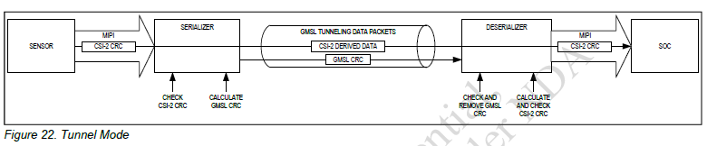

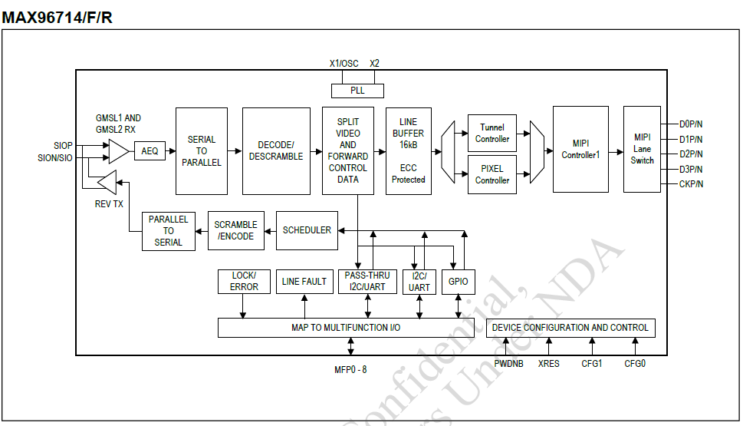

Video Memory ECC Protection
The integrity of data propagating through the pipe’s line memory is guaranteed by ECC, which enables correction of 1-bit errors and detection of 2-bit errors per 32 bits of video data.
The state of the ERRB pin (DES_ISP_MFP8) and error status register FS_INTR1 can be used to detect the presence of mempry ECC errors. Intentional memory error injection is available for diagnostic purposes. See register MEM_ECC0/1/2 for more information and to set up thresholds to detect these errors.
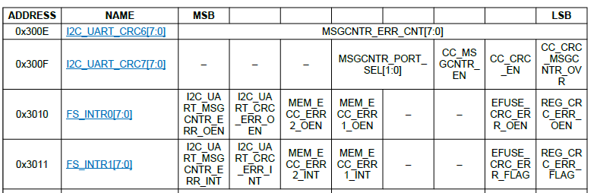
Question:. Intentional memory error injection – at startup for latent fault detection? See: MEM_ECC0/1/2
Question: Video PRBS Generator/Checker (see: p. 36 of GMSL2_Customers_MAX96714_F_R DS & Reg Doc (rev2).pdf)– at startup for for latent fault detection?

Question: does VOLVO need Frame Sync?(see: p. 36 of GMSL2_Customers_MAX96714_F_R DS & Reg Doc (rev2).pdf); unser Layout scheint vorbereitet zu sein:

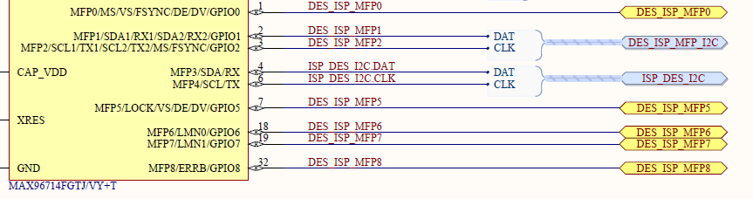

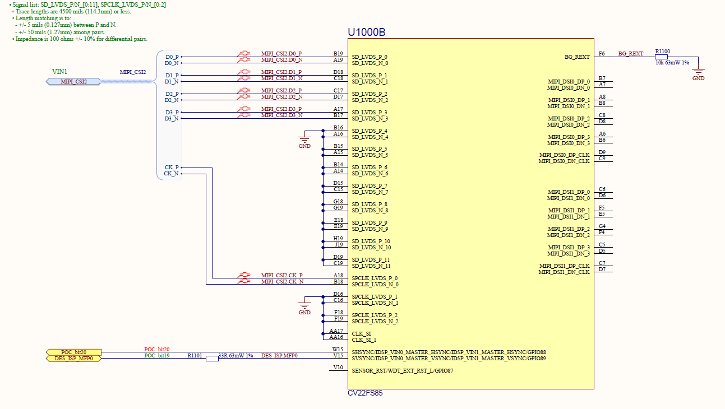
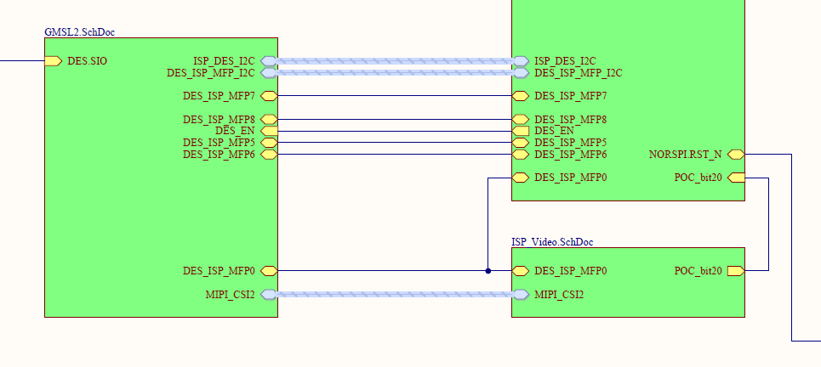

Vertical and Data Enable or Data Valid Sync Outputs
The MAX96714/MAX96714F/MAX96714R can output the Vertical Sync (VS) and Data Enable/Data Valid (DE/DV) of a video stream to monitor the video timing by a processor. This feature provides access to VS and DE/DV signals not available directly at the CSI-2 output. The VS and DE/DV output are alternate functions of MFP0 and MFP5.

Question: Do we need Scheduler/Arbiter? (p. 37 of GMSL2_Customers_MAX96714_F_R DS & Reg Doc (rev2).pdf),
The scheduler transmits packets with high-priority values before lower-priority values. Each communication transmit adapter sets a priority for the packet request before transmitting data to the remote side. The priority value is 2 bits, which allows for the following settings: 0 = Low, 1 = Normal, 2 = High, and 3 = Urgent - See TR0 for setting up priority. The scheduler, provided sufficient link bandwidth and chooses to transmit the packet with the highest priority among the see: TR0 – ATTENTION: no line/pin of this name on the schematics!

Message Counter
An additional functional safety feature of the MAX96714/F is the message counter, which can be used with the I2C/UART CRC feature.
Question: How to use Message Counter? Why it is used with I2C/UART? Is it only for I2C communication?
- Host: SoC (host of the I2C bus)
- ANSWER: YES, it is used for I2c/UART communication
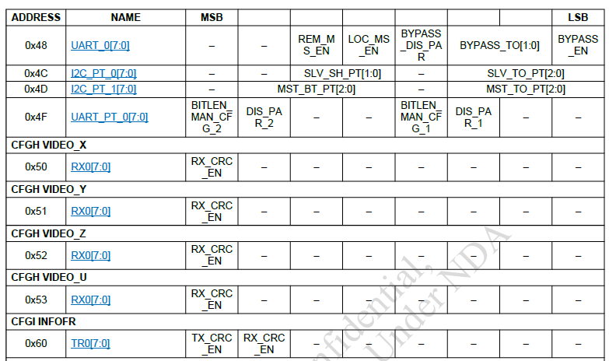

Question: LockOnMFP5 how the DES_ISP_MFP5 is used in the SOC and deserializer (as Lock indicator or in some other way?) Lock is by default!
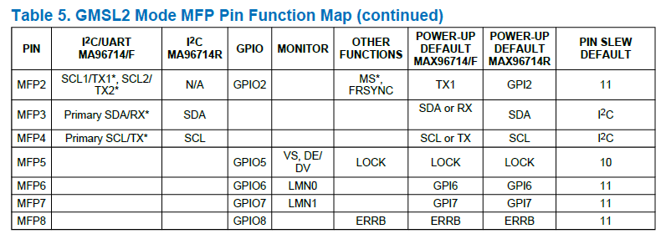
Answer:
- #1
  - “Multifunction Pin Assignments
  - The MAX946714/F/R provide a range of peripheral I/O functions. These functions are mapped through the register control to an array of multifunction pins (MFP). Each MFP has several possible functions, but only one can be used at a time. A user selects an MFP function to suit their use-case by programming the appropriate registers: FRSYNC = FSYNC_0 | VS = CFG_0/1 | DE = CFG_2/4 |.”, see: \\erg-fs-p1.mekra.net\MLG\TS-E\04 Wissensdatenbank\Datenblätter\HW\Aktive Bauelemente\LVDS\Maxim\GMSL2\MAX96714\Datasheets\GMSL2_Customers_MAX96714_F_R DS & Reg Doc (rev2).pdf
  - 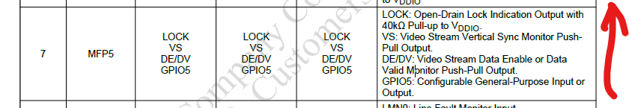
  - 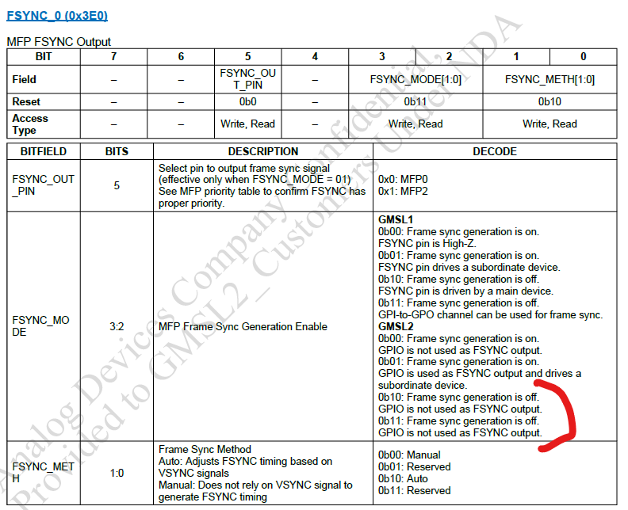
  - 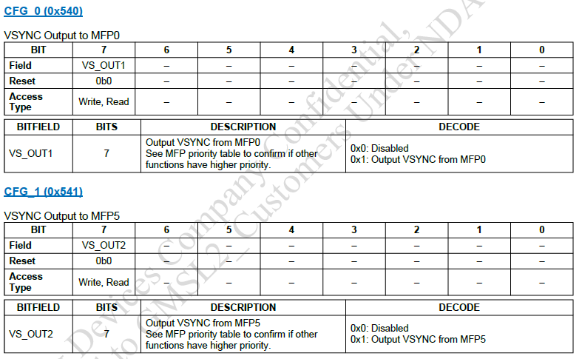
  - 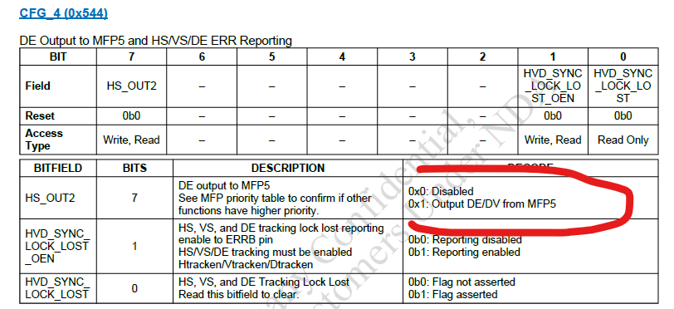
  - 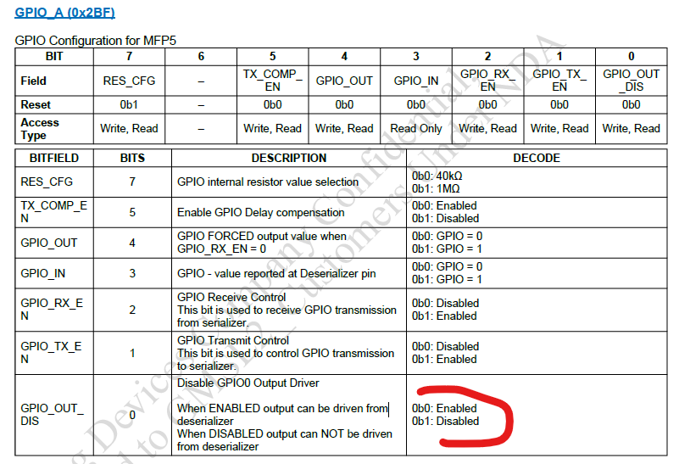
  - Question:
    - What happens if the LOCK is lost?
      - Is there SM to detect and indicate it?
      - Answer: Yes -> SM6 (LOCK indicator of Forward Channel (LOCK pin asserted in case of timing errors or no lock at the deserializer side)
      - ERGO: Requirement: system needs to be configured to receive LOCK on the MFP5!
Question: do we have 1MOhm?
“When relying on the ERRB pin to convey the occurrence of an undervoltage event, connect an external 1MΩ resistor between the ERRB pin and ground, because ERRB is not a power-up default MFP function. As a result, following a reset that is triggered by an undervoltage event, the ERRB MFP pin reverts to high impedance as opposed to ERRB. During an error state, the host device expects ERRB to drive logic-low, and the presence of the aforementioned resistor enables the appropriate logic level to be maintained following the reset, alerting the host device that attention is required.”

Question:
- What are the MIPI PHY Settings (output data rate, number of lanes, and port selection) at SoC that may be in conflict with Deserializer settings? (see: Table 10. MIPI PHY Settings Register Table in ApplNotes); default: D_i_P/N assingned to Data Lane I (see: MIPI_PHY3 (0x333) of DataSheet), MIPI_PHY2 (0x332) – for putting Put PHY into standby mode if not used to save power. (default setting); use MIPI_PHY0 (0x330) – use for MIPI loopback test or pattern generation
- Should we use Video Pipe Y to MIPI PHY Controller Register or leave it as default (no mapping)? (ApplNotes, Table 9) -> recommendation: no mapping
- Are there any Safety Mechanisms to detect MIPI PHY settings change? (see: Table 10. MIPI PHY Settings Register Table of ApplicationNotes)
- Do we need deskew? (see: chapter “MIPI D-PHY Deskew Settings” in ApplicatonNotes)

For reset of MIPI Controllers, see: bit DP_RST_MIPI_CHKB of register DP_ORSTB_CTL (0x577) AND bit RST_MIPITX_LOC of register: MIPI_PHY15 (0x33F)

Determines CSI PHY1 output frequency in multiples of 100Mbps/lane. Default is 1500Mbps/lane. See: register: BACKTOP25 (0x320) I Datasheet

Recommendation:
- No D-PHY lane Swap shall be allowed (default begavior). No D-PHY lane Polarity Swap shall be allowed (default begavior)
- No extended virtual channels shall be used
- No DT(Data Type), VC(virtual Channel), bpp(bits per pixel) override shall be used

Question to Copilot:
what is a frame format of the i2c write command?
The I²C (Inter-Integrated Circuit) protocol uses a well-defined frame format for communication between a master and one or more slave devices. Here's the frame format specifically for an I²C write command:

🧩 I²C Write Frame Format
An I²C write operation typically consists of the following sequence:
[S] [Slave Address + W] [ACK] [Register Address] [ACK] [Data Byte(s)] [ACK] ... [P]

Breakdown:
Segment | Description
S (Start Condition) | Initiated by the master to begin communication
Slave Address + W | 7-bit slave address + 1-bit write flag (0)
ACK | Acknowledge bit from the slave (pulled low if acknowledged)
Register Address | Address of the register to write to (1 byte typically)
ACK | Acknowledge from the slave
Data Byte(s) | One or more bytes of data to be written
ACK | Acknowledge after each data byte
P (Stop Condition) | Indicates end of transmission

🧠 Example
Suppose you want to write 0xAB to register 0x10 of a device with address 0x50:
Start → 0xA0 → ACK → 0x10 → ACK → 0xAB → ACK → Stop
- 0xA0 is 0x50 << 1 | 0 (write bit = 0)
- 0x10 is the register address
- 0xAB is the data byte

Would you like a diagram showing this frame visually or an example in code (e.g., using Arduino or Python)?

I2C Writes with CRC (p. 38 of the document)
Question: What is the CRC polynomial? Is it strong enough to for FuSa related parameters?
ANSWER: The degree of the polynomial is of degree == 8. Suspision: 0xA6 = (x8 +x6 +x3 +x2 +1)‡, acc. to –dsn04_koopman_crc_preprint.vp the Hamming Distance can reach ==3 for data word lengths of 247bits (see Table 3 of dsn04_koopman_crc_preprint.vp)
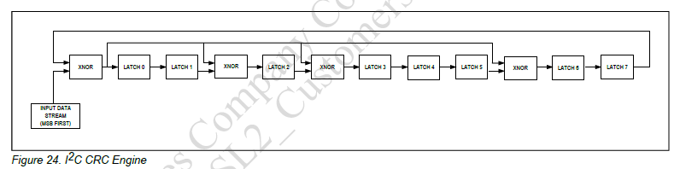
See also:
- dsn04_koopman_crc_preprint.vp
  - 0xA6 = (x8 +x6 +x3 +x2 +1)‡ !!!
- CRC Calculation Circuit
- Untitled Document
- 8 Bit CRC Zoo
- an296177-crc-algorithms-in-sensor-communication.pdf
  - See: p. 3/22
- Sunshine's Homepage - Understanding CRC
- CRC Generating and Checking,
- CRC calculator, link

Question to Copilot
what does bound in crc (Cyclic redundancy code) technique context mean?
In the context of CRC (Cyclic Redundancy Check), the term "bound" can have a few different meanings depending on the technical context. Here are the most relevant interpretations:

1. Error Detection Bound
In error detection theory, a bound refers to the maximum number of errors that a CRC code can reliably detect. For example:
- A CRC with a certain polynomial might be guaranteed to detect all single-bit and double-bit errors, and burst errors up to a certain length.
- This is often called the error detection capability bound.

2. Mathematical Bound on Polynomial Properties
CRC uses polynomials over GF(2) (binary field). The bound might refer to:
- The degree of the generator polynomial, which bounds the length of the CRC checksum.
- The minimum Hamming distance between valid codewords, which bounds the error detection capability.

3. Performance Bound
In implementation contexts, "bound" might refer to:
- Computational bounds: limits on how fast CRC can be computed (e.g., in hardware or software).
- Memory bounds: limits on lookup table sizes used for fast CRC computation.

Example:
If a CRC polynomial is said to have a burst error detection bound of 16, it means it can detect any burst error of up to 16 bits.

Would you like a deeper dive into one of these meanings, such as how bounds are calculated or how they affect CRC design in safety-critical systems like automotive (e.g., ISO 26262)?

Question to Copilot:
could you provide a relevant example code in python?

Here’s a simple example of how to perform an I²C write operation in Python using the popular smbus2 library, which is commonly used on platforms like Raspberry Pi:

🐍 Python Code Example: I²C Write
from smbus2 import SMBus

# I2C bus number (usually 1 on Raspberry Pi)
busnumber = 1

# Device and register addresses
deviceaddress = 0x50 # Example I2C device address
registeraddress = 0x10 # Register to write to
datatowrite = 0xAB # Data byte to write

# Open the I2C bus and write
with SMBus(busnumber) as bus:
bus.writebytedata(deviceaddress, registeraddress, datatowrite)
print(f"Written 0x{datatowrite:02X} to register 0x{registeraddress:02X} of device 0x{deviceaddress:02X}")

🧰 Requirements
- Install the library: pip install smbus2
- Run on a system with I²C enabled (e.g., Raspberry Pi with I²C enabled via raspi-config).

Would you like an example for multi-byte writes or reading from an I²C device as well?

Question to Copilot:
how to determine a CRC polynomial from a diagram with XOR gates and register bits?
To determine a CRC (Cyclic Redundancy Check) polynomial from a diagram with XOR gates and register bits, you're essentially reverse-engineering the polynomial from a Linear Feedback Shift Register (LFSR) circuit. Here's how to do it step by step:

🧩 Step-by-Step Guide

1. Identify the Register Length
- Count the number of flip-flops (register stages). This gives you the degree of the polynomial.
  - Example: 8 flip-flops → polynomial of degree 8 → starts with ( x^8 )

2. Locate XOR Taps
- Look for the lines that feed back through XOR gates into the input of the first register.
- Each tap corresponds to a term in the polynomial.

3. Map Tap Positions to Polynomial Terms
- Label the registers from right to left as ( x^0, x^1, …, x^n )
- If a tap connects to register ( x^k ), then the polynomial includes the term ( x^k )

4. Construct the Polynomial
- Always include the highest degree term ( x^n ) and the constant term ( 1 )
- Add terms for each XOR tap
- Example: taps at ( x^8, x^2, x^1, x^0 ) → polynomial is: $ x^8 + x^2 + x^1 + 1 $

🔧 Example
Suppose you have a diagram with:
- 8 registers
- XOR taps at positions 8, 2, 1, and 0
Then the CRC polynomial is:
x^8 + x^2 + x + 1
In hexadecimal (used in code), this would be:
0x107 (binary: 0001 0000 0111)

Would you like to upload a diagram for analysis or see how this polynomial is used in Python code for CRC computation?

Question to Copilot:
what is the packet format of GMSL2 protocol?

The GMSL2 (Gigabit Multimedia Serial Link 2) protocol, developed by Maxim Integrated (now part of Analog Devices), uses a packet-based, full-duplex serial communication architecture designed for high-speed video and data transmission in automotive and industrial applications.

📦 GMSL2 Packet Format Overview
While the full packet structure is proprietary and detailed in Analog Devices documentation, here are the key elements based on the GMSL2 General User Guide[1]:

1. Physical Layer (PHY)
- Forward Channel: 3 Gbps or 6 Gbps
- Reverse Channel: 187.5 Mbps
- Uses coaxial or shielded twisted pair cables
- Supports spread-spectrum clocking and forward error correction (FEC)

2. Packet Structure Components
Although the exact byte-level format is not publicly disclosed, GMSL2 packets typically include:
- Header: Identifies packet type (video, control, audio, etc.)
- Payload: Contains the actual data (e.g., video frame, I2C command, audio stream)
- CRC/Error Correction: Ensures data integrity using CRC and ARQ mechanisms
- Control Signals: Embedded for synchronization (e.g., HSYNC, VSYNC, DE)

3. Video Transmission Format
- Video data is transmitted in frame-based packets
- Includes active video and blanking intervals
- Sync signals (HSYNC, VSYNC) are embedded in the stream
- Supports Display Stream Compression (DSC) for 4K video

4. Bidirectional Communication
- Reverse channel supports:
  - I2C/UART
  - GPIO signaling
  - SPI
  - Audio return
- Control latency is typically <10 µs

5. Error Handling
- Forward Error Correction (FEC)
- CRC error detection
- Automatic Repeat Request (ARQ) for retransmission

Would you like a diagram illustrating the packet flow or a breakdown of how video and control data are multiplexed in GMSL2?
References
[1] www.analog.com

Question to Copilot
could you give some more details wit respect to the size of the packet structure components?
The GMSL2 protocol packet structure is proprietary and not fully disclosed publicly, but based on the official GMSL2 Channel Specification User Guide from Analog Devices[1], we can extract some key details about the size and structure of its components:

📦 GMSL2 Packet Structure Components and Sizes

1. Video Packet Size
- Each video packet typically contains:
  - 36 pixels
  - 1-bit sequence number for dropped packet detection[2]
This implies that the payload size depends on the pixel format (e.g., RGB888 = 3 bytes/pixel → 108 bytes per packet).

2. Forward Channel Data Rate
- Operates at 3 Gbps or 6 Gbps
- Uses NRZ encoding, so effective bandwidth is half the link rate:
  - 3 Gbps → 1.5 GHz
  - 6 Gbps → 3 GHz

3. Reverse Channel Data Rate
- Fixed at 187.5 Mbps
- Used for control signals, I2C/UART, GPIO, etc.

4. Insertion Loss Limits
- Defines how much signal loss is acceptable across the transmission medium:
  - −19.5 dB at 1.5 GHz for 3 Gbps
  - −21 dB at 3 GHz for 6 Gbps[1]

5. Return Loss Limits
- Ensures minimal signal reflection:
  - Calculated using frequency-dependent equations
  - Important for maintaining signal integrity

6. Crosstalk Limits
- Broadband Crosstalk: < 4 mV peak-to-peak across 1 MHz to 4 GHz
- Narrowband Crosstalk: Frequency-dependent limits, e.g.:
  - 0.1–1 MHz: up to 40 mV
  - 100–400 MHz: down to ~20 mV[1]

🔧 Additional Notes
- Idle Data: When the payload is smaller than the link capacity, idle data fills the gap.
- Error Correction: Uses Forward Error Correction (FEC) and CRC for reliability.
- Packet Overhead: Includes headers, sync signals (HSYNC, VSYNC), and control bits.

Would you like a visual diagram of the packet structure or a breakdown of how control and video data are multiplexed?
References
[1] www.analog.com
[2] ez.analog.com

I2C communication with deserializer
The addresses and values of the registers are bytes ->
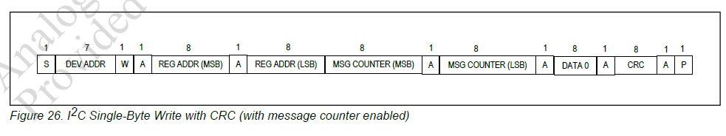
In this casae there are 4 till 6 Bytes (32 – 48 bits) that are protected by CRC:
- Device Address
- Reg address (MSB)
- Reg address (LSB)
- [Optional] Msg counter MSB
- [Optional] Msg counter LSB
- Data 0

I2C communication with Camera Sensor via deserializer
SOW1 register addresses are 16bit
SOW1 register values are 16 bits
What is the DevAddress of SOW1::Imager? -> how to obtain this address?
For this communication “I2C Multiple-Byte Write with CRC” must(?) be used
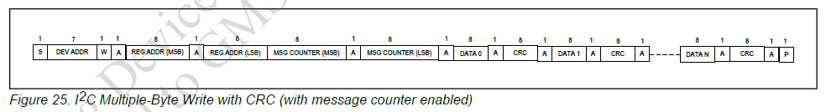

Question to ANALOG Devices:
Questions:
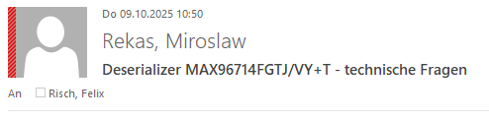
- What is the generator polynomial for i2c communication with external uController?
  - I presume it is G(x) == x^8 + x^6 + x^3 + x^2 +1 which corresponds to 0xA6 polynomial (please ref. to Figure 24 on page 38 of “I2C CRC Engine of Single GMSL2/GMSL1 to CSI-2 Deserializer”, 19-101134; Rev 2; 6/23)
  - Could you confirm this?
- What is the Hamming Distance for this polynomial for the following data word lengths
  - 32 bit
  - 40bit
  - 48 bit
  - 56 bit
- In case of i2c forwarding towards image sensor… Does the communication attributes remain the same on the Deserializer – Sensor link as they was set-up for the Deserializer-uController link?

Question: Do we ‘cut through’ for speeding up the process?
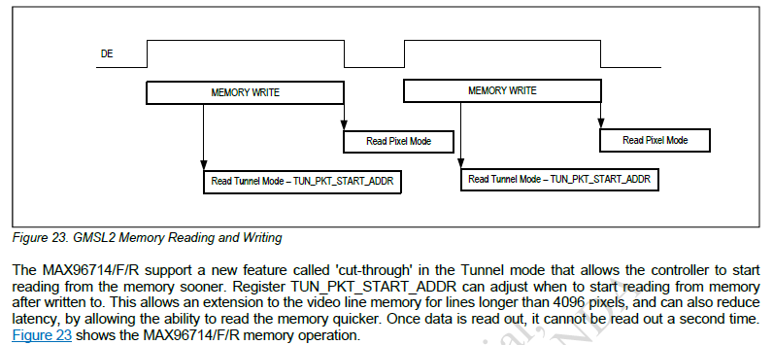

Question to Copilot
what is forward error correction (FEC)?

Forward Error Correction (FEC) is a technique used in digital communication systems to detect and correct errors in transmitted data without needing retransmission. It’s especially useful in high-speed or noisy environments—like automotive video links (e.g., GMSL2)—where retransmitting data isn't practical due to latency or bandwidth constraints.

🔧 How FEC Works
- Encoding:
  - Before transmission, the sender adds redundant bits (called parity or check bits) to the original data using a mathematical algorithm.
  - These bits form a codeword that contains both the data and error-correcting information.
- Transmission:
  - The encoded data is sent over the communication channel.
  - Noise or interference may corrupt some bits.
- Decoding:
  - The receiver uses the redundant bits to detect and correct errors.
  - If the number of errors is within the correction capability of the code, the original data is recovered perfectly.

🧠 Common FEC Algorithms
- Hamming Codes: Corrects single-bit errors, detects two-bit errors.
- Reed-Solomon Codes: Widely used in CDs, DVDs, and digital TV.
- LDPC (Low-Density Parity-Check): Used in modern high-speed systems like 5G and GMSL2.
- Turbo Codes: Used in deep-space and mobile communications.

📈 Benefits of FEC in GMSL2
- Low Latency: No need to wait for retransmission.
- High Reliability: Maintains video and control signal integrity.
- Efficient Bandwidth Use: Reduces overhead compared to ARQ (Automatic Repeat Request).

Would you like a visual example of how FEC corrects errors in a data stream or a comparison between FEC and other error-handling methods like CRC or ARQ?

Question to Copilot
Compare FEC with ARQ and CRC

Here's a comparison of Forward Error Correction (FEC), Automatic Repeat Request (ARQ), and Cyclic Redundancy Check (CRC)—three key techniques used to ensure data integrity in communication systems:

📊 Comparison Table
Feature | FEC (Forward Error Correction) | ARQ (Automatic Repeat Request) | CRC (Cyclic Redundancy Check)
Error Handling Method | Adds redundant data to correct errors | Requests retransmission if errors are detected | Detects errors but does not correct them
Retransmission Needed? | ❌ No | ✅ Yes | ❌ No (but often used with ARQ)
Latency | Low (no retransmission delay) | High (depends on round-trip time) | Low
Bandwidth Efficiency | Lower (due to redundancy overhead) | Higher (only retransmits when needed) | High (minimal overhead)
Complexity | High (requires encoding/decoding) | Moderate (requires protocol for retransmission) | Low (simple polynomial check)
Use Cases | Real-time video/audio, satellite, GMSL2 | TCP/IP, file transfers, reliable messaging | Ethernet, storage, embedded systems
Error Correction Ability | ✅ Yes (within limits) | ✅ Yes (via retransmission) | ❌ No (only detection)

🔍 Summary
- FEC is ideal for real-time or high-speed systems (like GMSL2) where retransmission is impractical. It corrects errors on the fly using added redundancy.
- ARQ is used in systems where reliability is more important than latency, like file transfers. It relies on error detection (often via CRC) and retransmission.
- CRC is a lightweight method to detect errors, often used in conjunction with ARQ or FEC. It’s fast and efficient but doesn’t correct errors.

Would you like a diagram showing how these methods work in a typical communication flow?

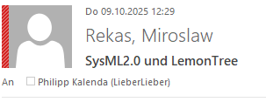

Functional Safety Features - POST/LBIST/MBIST – CRC
- POST (power on self test)
  - LBIST
  - MBIST
  - Has status registers for each test -> REG_POST0 - register
  - A failure does not prevent the device from operation but does assert ERRB.
- CRCs
  - Forward Channel CRC -> register: RX1
  - Reverse Channel CRC -> TR0
  - External I2C/UART CRC -> I2C_UART_CRC7
  - Info Frame Forward and Reverse channel CRC, FWD - Video info frames -> TR0
  - Video Line CRC -> VIDEO_RX0
    - Only in Pixel Mode?
  - Video Packet CRC -> INTR6
  - Tunnel Mode CRC -> MIPI_PHY16
  - GPIO Forward and Reverse channel CRC -> TR0 GPIO CRC
  - Pass-Through Forward and Reverse channel 1 and 2 CRC -> TR0 Pass-through 1 / 2
  - RBB Reverse Channel CRC -> FAULT_OEN
  - Line Memory ECC – CRC -> FS_INTR0

\\erg-fs-p1.mekra.net\MLG\TS-E\04 Wissensdatenbank\Datenblätter\HW\Aktive Bauelemente\LVDS\Maxim\GMSL2\MAX96714\Application Notes\GMSL2_Customers_max96714fr-user-guide_rev0.pdf

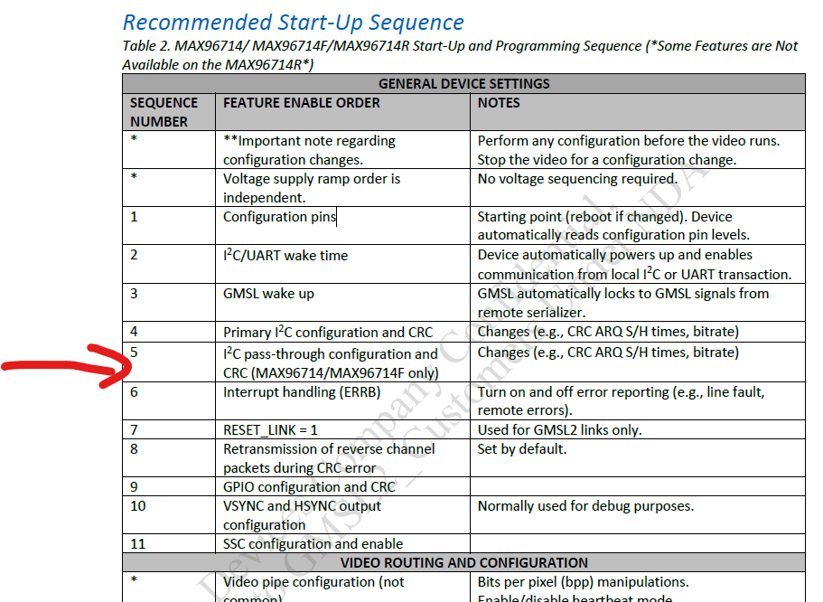

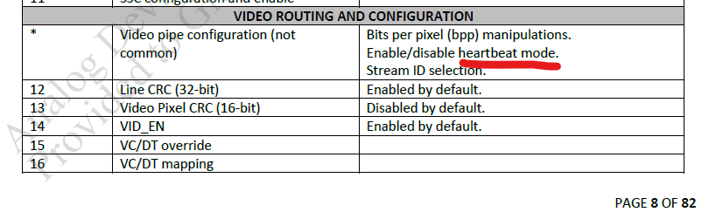
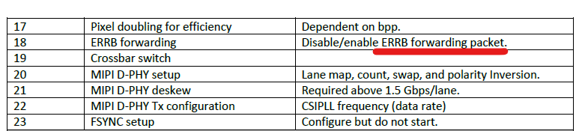

ATTENTION!
Enable the video only after the video path is configured; dynamic configuration is not supported.
In the tunneling mode, any combination of data type, bits per pixel (bpp),
and virtual channel may be transmitted if the video bandwidth total does not exceed the link bandwidth.

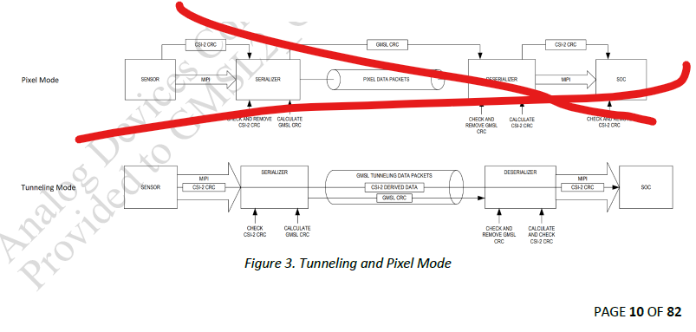
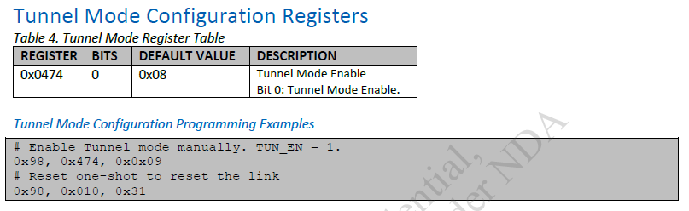

\\erg-fs-p1.mekra.net\MLG\TS-E\04 Wissensdatenbank\Datenblätter\HW\Aktive Bauelemente\LVDS\Maxim\GMSL2\MAX96714\Datasheets\GMSL2_Customers_MAX96714_F_R DS & Reg Doc (rev2).pdf
enableTunnelMode
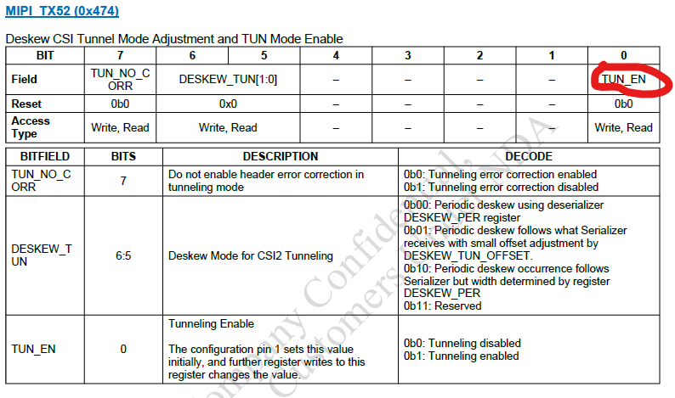
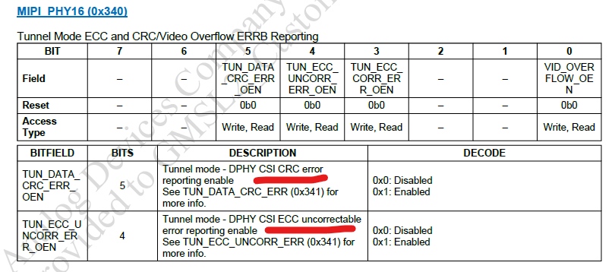
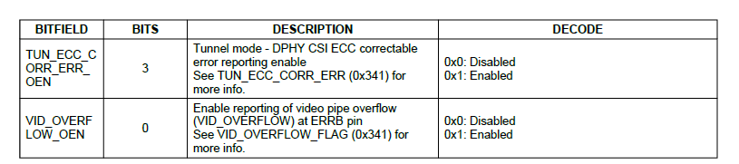

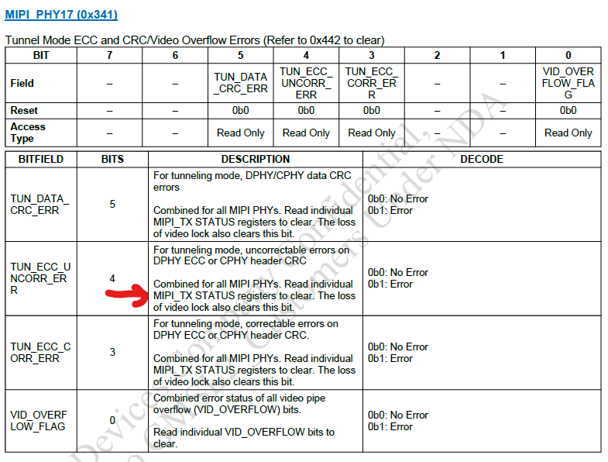
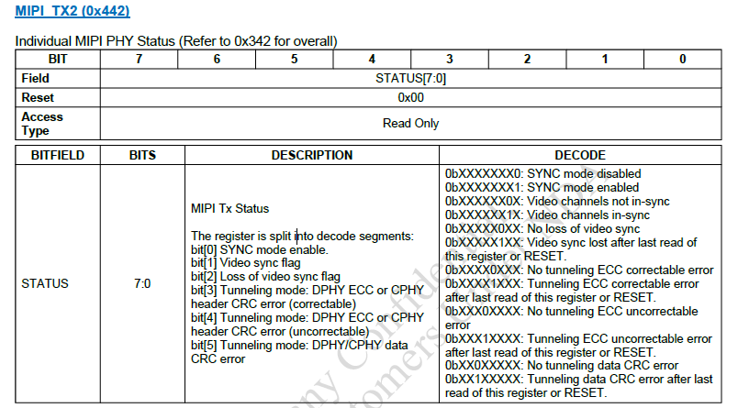

Question to CoPilot:
hi! could you tell me what 'Deskew Mode for CSI2 Tunneling' is?
"Deskew Mode for CSI-2 Tunneling" refers to a calibration mechanism used in MIPI CSI-2 (Camera Serial Interface 2) systems to correct timing mismatches—called skew—between multiple data lanes during high-speed data transmission.
Here’s a breakdown of the concept:

🔧 What is Deskewing in CSI-2?
In MIPI CSI-2 systems, especially those using MIPI D-PHY, data is transmitted over multiple lanes in parallel. Due to physical differences in trace lengths or environmental factors (like temperature or voltage drift), signals may arrive at slightly different times across lanes. This mismatch is called skew.
Deskewing is the process of aligning these signals so that the receiver can correctly interpret the data.

🧠 Types of Deskewing
- Initial Deskewing:
  - Performed once during startup.
  - Ensures lanes are aligned before data transmission begins.
- Periodic Deskewing:
  - Performed at intervals during operation.
  - Helps maintain alignment over time, especially at high data rates (>1500 Mbps), where drift can accumulate.
  - Requires the transmitter (TX) to send a deskew calibration pattern periodically.

🛠️ Deskew Mode in CSI-2 Tunneling
When CSI-2 data is tunneled through another protocol (e.g., GMSL3 or over long-distance links), deskewing becomes even more critical. In this context:
- Deskew Mode ensures that the receiver (RX) can detect and correct skew dynamically.
- The deskew pattern (often 8192 UI or more) is sent by the transmitter to allow the receiver to recalibrate.
- This mode is typically configurable in IP cores (e.g., AMD/Xilinx MIPI D-PHY RX IP) and may be enabled via GUI or registers[1].

⚠️ Considerations
- Periodic deskewing is optional but recommended for high-speed links.
- If not properly configured, enabling periodic deskewing can cause transmission errors (e.g., CRC errors or frame drops)[2].
- The deskew pattern duration and frequency must be tuned based on system characteristics and sensor capabilities[3].

Would you like help configuring deskew settings for a specific hardware setup or IP core?
References
[1] adaptivesupport.amd.com
[2] adaptivesupport.amd.com
[3] adaptivesupport.amd.com

\\erg-fs-p1.mekra.net\MLG\TS-E\04 Wissensdatenbank\Datenblätter\HW\Aktive Bauelemente\LVDS\Maxim\GMSL2\MAX96714\Application Notes\GMSL2_Customers_max96714fr-user-guide_rev0.pdf
TunnelModeHardWired1
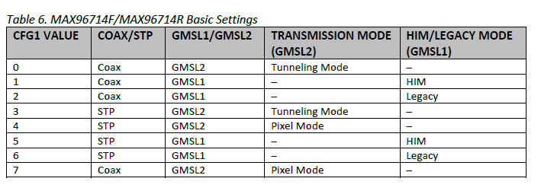
The selected configuration becomes the new default on power-up once the CFG pins are set and the part is power cycled.

\\erg-fs-p1.mekra.net\MLG\TS-E\04 Wissensdatenbank\Datenblätter\HW\Aktive Bauelemente\LVDS\Maxim\GMSL2\MAX96714\Datasheets\GMSL2_Customers_MAX96714_F_R DS & Reg Doc (rev2).pdf
TunnelModeHardWired2
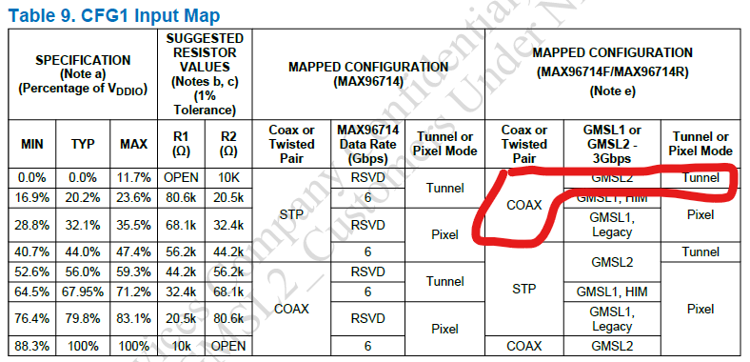

\\erg-fs-p1.mekra.net\MLG\TS-E\04 Wissensdatenbank\Datenblätter\HW\Aktive Bauelemente\LVDS\Maxim\GMSL2\MAX96714\Application Notes\GMSL2_Customers_max96714fr-user-guide_rev0.pdf
LinkInitialization
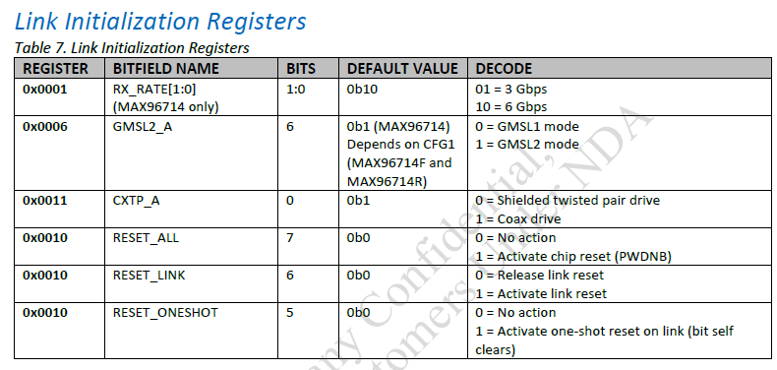

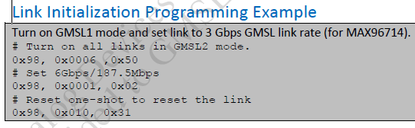
0x98 – I2C address (hardwired CF0 pin)
0x0006 – Register: REG6 (0x6) GMSL and UART/I2C Configuration
0x05 == 0b0101 000 -> GMSL2_A == 1 and I2CSEL == 1
Note: This bit (I2CSEL) is set according to the CFG0 pin value on power-up. Writing to this register is not recommended.
ApplicationNote
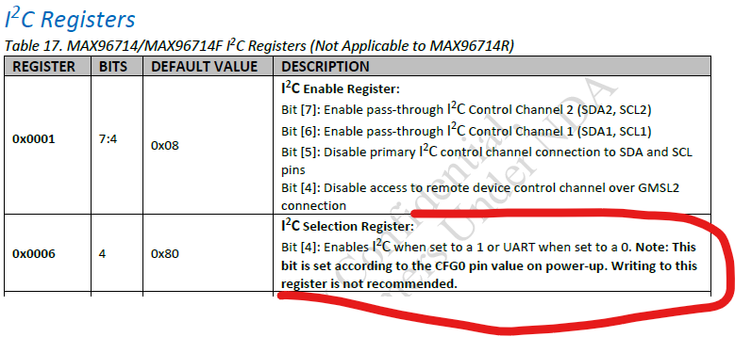

E-mail:
\\erg-fs-p1.mekra.net\MLG\TS-E\ASPICE-FuSi Engineer\projekte\VOLVO\SOW2\FuSa\FSRs\smallReview\EXT RE Deserializer MAX96714FGTJVY+T - technische Fragen.msg

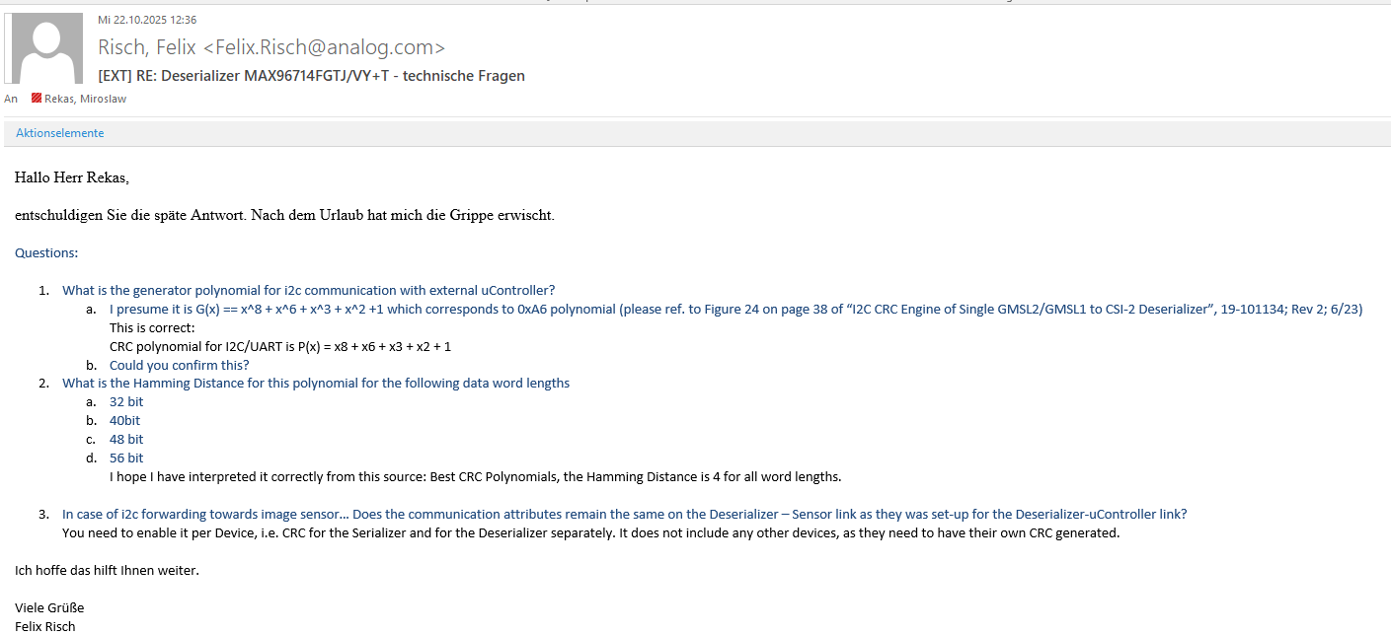

SelectingPipeStream
Appl note
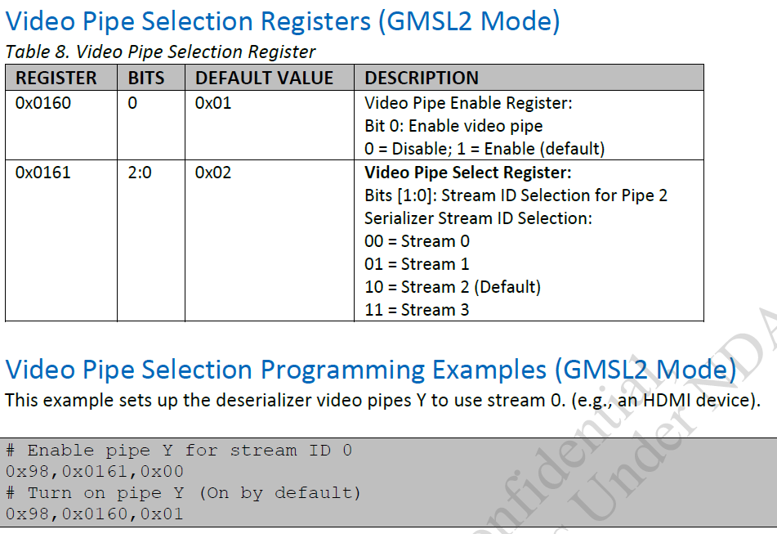
datasheet
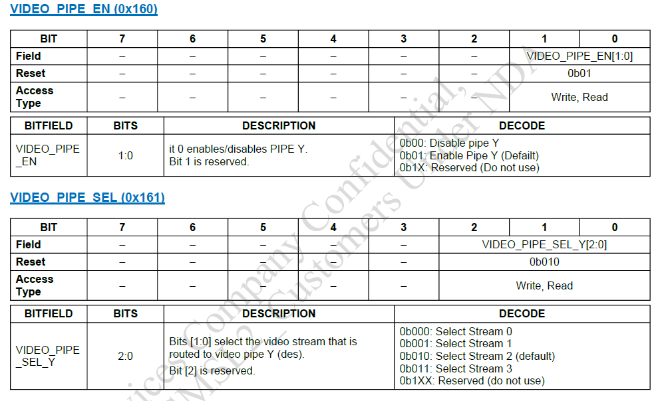

I2C for CRC + Message Counter
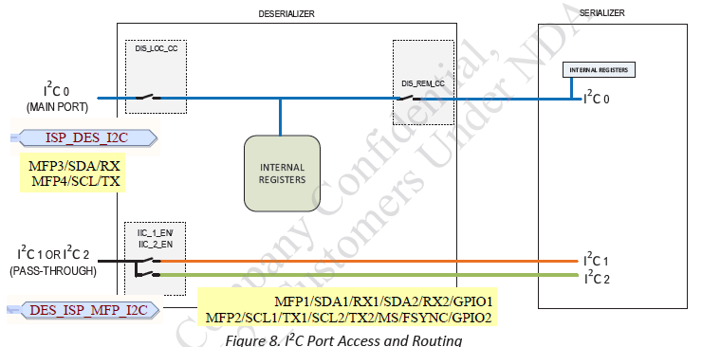
The MAX96714 provides two additional functional safety features by adding an optional CRC packet to either side of the link and an optional message counter to monitor both write and read transactions. Both features are available only to the deserializer’s primary I2C control channel for register read/write transactions. They are disabled by default and must be enabled at the register level.

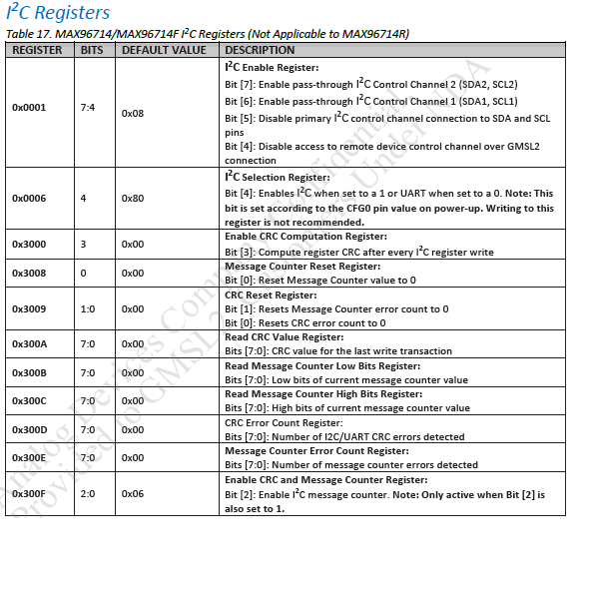
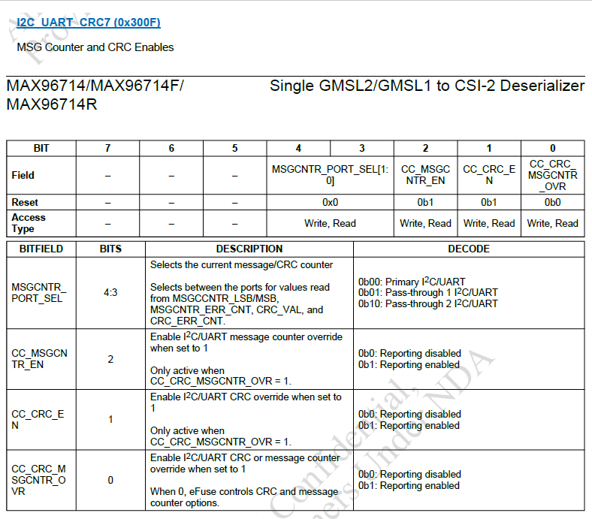

CRC over I2C: to enable this feature:
- Set bit CC_CRC_EN to one, of the register I2C_UART_CRC7(0x300F)
- Set bit CC_CRC_MSGCNTR_OVR to one, of the register I2C_UART_CRC7(0x300F)
Message Counter over I2C: to enable this feature:
- Set bit CC_MSGCNTR_EN to one, of the register I2C_UART_CRC7(0x300F)
- Set bit CC_CRC_MSGCNTR_OVR to one, of the register I2C_UART_CRC7(0x300F)

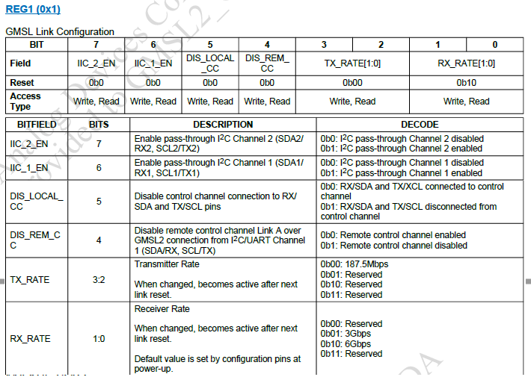
Procedure:
- Set bit IC_1_EN to 0b1 of register: REG1(0x1) to enable pass-throug I2C channel from des to ISP
- Set bit DIS_LOCAL_CC to 0b0 of register: REG1(0x1) to enable primary control channel (Link A) access deserializer register
- Set bit DIS_REM_CC to 0b0 of register: REG1(0x1) to enable primary control channel (Link A) access serializer register
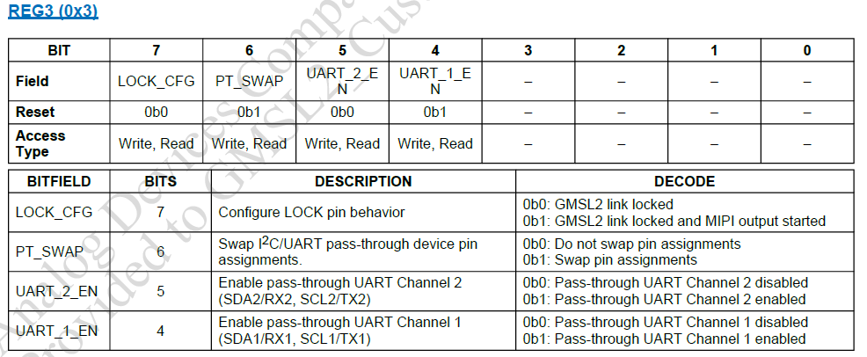
Disable UART on Channel 1by setting bit UART_1_EN to zero of the register: REG3(0x03)

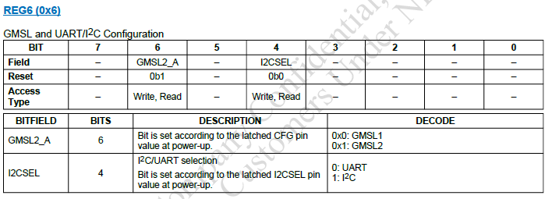
Procedure:
- Check if bit I2CSEL is set 1 (acc. to wiring) to enable i2c communication (primary and channel 1)
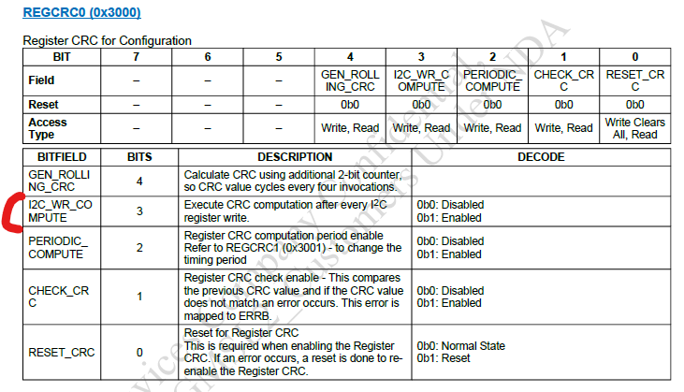
Procedure:
- Set bit I2C_WR_COMPUTE to 0b1 of register REGCTC0 (0x3000)
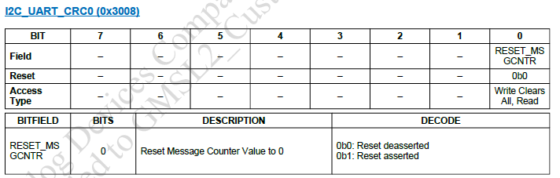
Procedure:
- Set RESET_MSGCNTR to 0b1 of the register: I2C_UART_CRC0(0x3008) to reset message counter

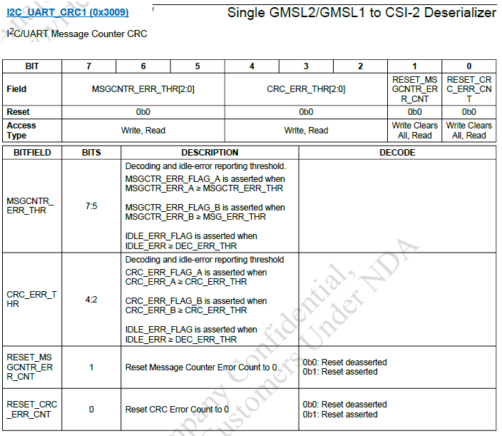
Procedure:
- Set bit RESET_MSGCNTR_ERR_CNT to 0b1, it resets Message Counter error count to 0
- Set RESET_CRC_ERR_CNT to 0b1, it resets CRC error count to 0

Procedure:
- Set bit CC_CRC_MSGCNTR_OVR to one, of the register I2C_UART_CRC7(0x300F)
- Set bit CC_MSGCNTR_EN to one, of the register I2C_UART_CRC7(0x300F)

p. 26 ApplicationNote

The MAX96714 provides two additional functional safety features by adding an optional CRC packet to either side of the link and an optional message counter to monitor both write and read transactions. Both features are available only to the deserializer’s primary I2C control channel for register read/write transactions. They are disabled by default and must be enabled at the register level.

